Credit processor initiation

Scenario: FC is emailing because credit processor is on gray

(These are AI images generated for reference purposes only.)

- To initialize your credit processor, go to the main screen of your POS.
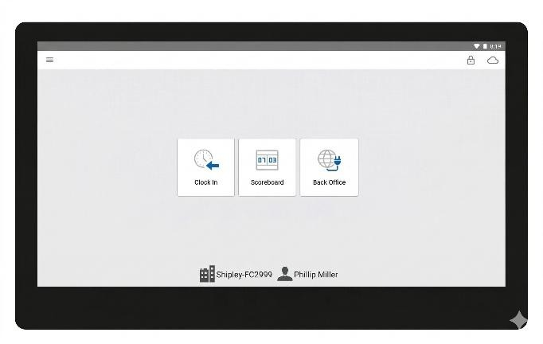

- Click on the cloud option in the top right corner. If you see the message "Credit processor not initialized," it means that your POS cannot accept payments.
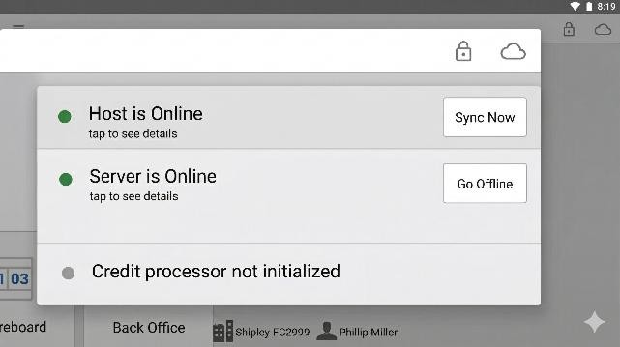

- Go back to the main screen and tap the three horizontal bars icon.
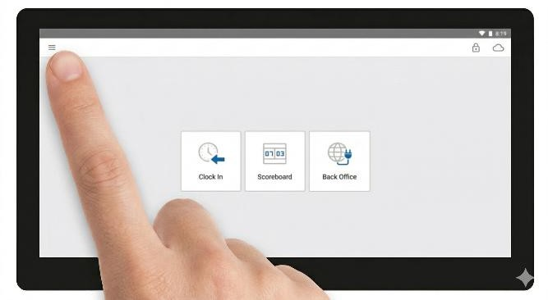
- Select the last option, "Setup Credit Processor," and click on it.
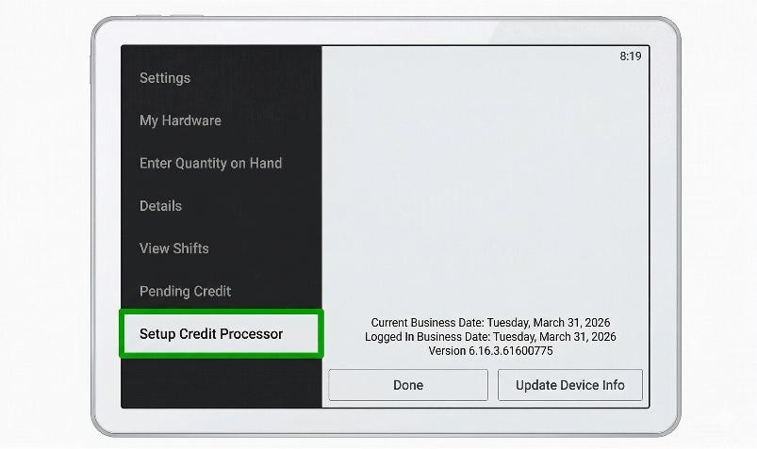
- This should initialize automatically, so just wait a few seconds

.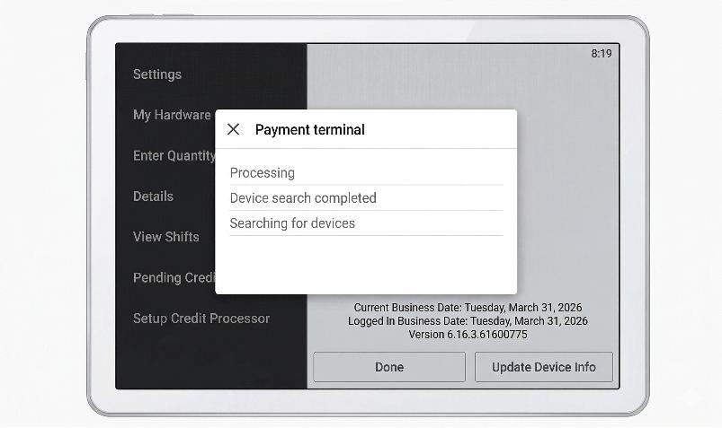

- The screen should display "Lane opened on device," which means the process was successful.
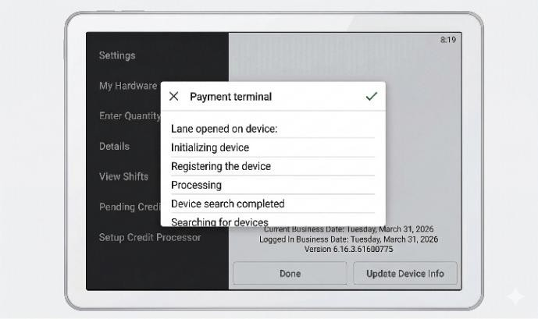

- Click the check mark in the top right corner.
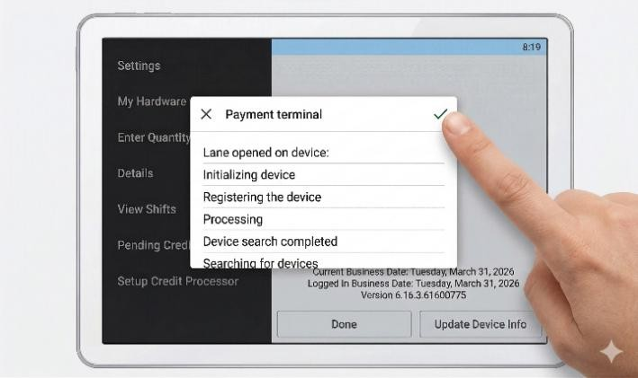

- We can see that the credit processor is back online.
- After this process, the POS should be able to accept cards. If not, reset the device and try the process again.
